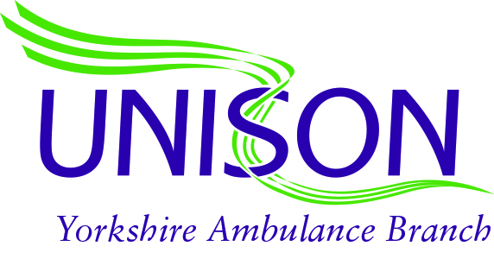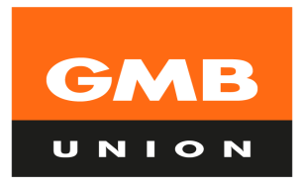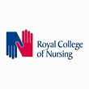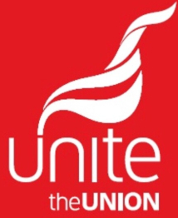

There has been a joint meeting of all Trade Unions (Staff side) within Yorkshire Ambulance Service to discuss the Trusts removal of staff from the RRV. It was unanimously agreed that enforcing changes rather than working with Staff side and members to find a sustainable and appropriate way forward is unacceptable.

The overall feeling from members and Staff side is that Trust Management has disregarded the hard work and service that our RRV members provide. When the COVID situation was at its peak previously our RRV members 'stepped up' and provided fantastic care and support on the DCA's despite their own reservations. These members, many of whom are vastly experienced, had recently gone through a restructure into a specific Specialist Paramedic role to ensure that patients receive the most appropriate care and ambulances are not activated to incidents where they are not required.

By the clumsy and overbearing approach the Trust has taken our members are now being made to feel undervalued and disenfranchised. There is already a clear agreement in place whereby members of the RRV team can be asked, not forced, to work on an ambulance. It appears yet again that this is only an agreement on paper. Whilst our members are expected to adhere to Trust agreements, Management have carte blanche to ignore them as and when they wish.

This is clearly not in line with partnership working and Staff side intend to inform its members that they should adhere to the current negotiated agreement until such time that this situation is resolved in an appropriate manner through dialogue and discussion.
​

UNISON GMB Unite the Union RCN

