UNISON Direct 08000 857 857
Yorkshire Ambulance Branch
02.11.2020
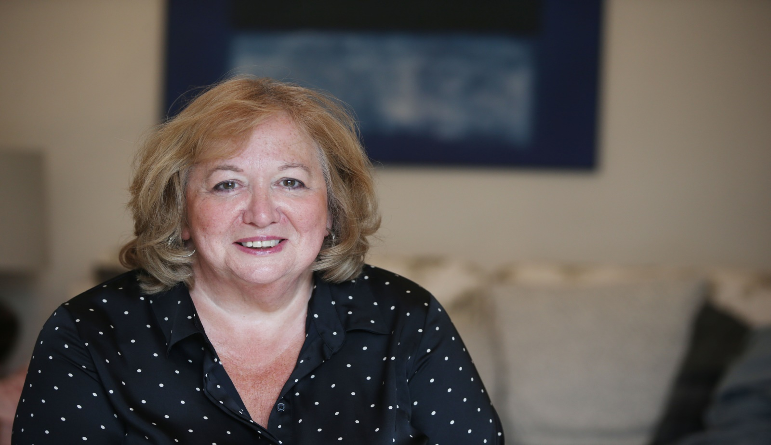

UNISON Yorkshire Ambulance Branch has nominated Christina McAnea to lead our 1.3 million members as General Secretary.

Christina has worked for UNISON for over 25 years. She is one of the UK’s most senior women trade unionists - a no non-sense negotiator and a champion for women’s rights, pay equality, justice for low paid workers and a strong supporter of political devolution.

She offers a clear, ambitious, responsible vision for our union’s future to support every UNISON member. Her election would be a real departure from the past as the first woman General Secretary.

