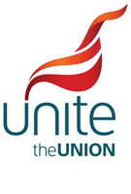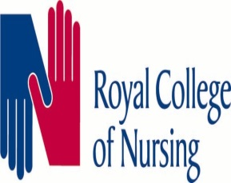
End of Shift Proposal
Vote Now
After a long period of discussion, Staffside has been given an agreed proposal to try and reduce the exceptional amount of end of shift overtime that our members are suffering on a daily basis.
The main points of the proposal are that the last 60 minutes of a shift will be split into three 20 minute segments, each gradually giving more protection.
The Last Hour
First 20 minutes – Cat 1 and 2 only
Second 20 minutes – Confirmed Cat 1 calls only
Third 20 minutes (up to finish time) – complete protection off the stack- only exceptions are major incident or flagged down

Alongside these changes will be an extention of the mealbreak window, currently a 2 hour window, extended to a 3 hour window. So 90 minutes either side of the mid point of the shift. Members will still be unavailable whilst on meal break, or if late to stand down. An optional change to this will be that members will now be available to volunteer to be available for CAT 1 calls during meal break. If activated to a call a payment of £20 will be received (no payment if not used). This is entirely voluntary and both crewmates must agree at the start of the shift.
In order to cover the changes, some stations whos current rotas show a number of crews finishing at the same time will be asked to tweak their rotas to stagger finishes and ensure relevant cover is maintained.
The full proposal is available and can be emailed, with the proposed rota changes attached. Staffside feel this is a huge step forward in cutting down on the excessive end of shift overtime our members are suffering and as such recommend accepting the proposal.
It is now over to you, the members, a ballot has been set up and all members of the recognised Trade Unions within YAS are encouraged to have their say.
This ballot is A&E frontline members only who are affected by this change
EACH TRADE UNION WILL HOLD THEIR OWN BALLOT WHICH WILL BE COLLATED AFTER THE CLOSING DATE FOR AN OVERALL RESULT
The ballot opens at midday 17th September 2021 until midday on 8th October 2021

