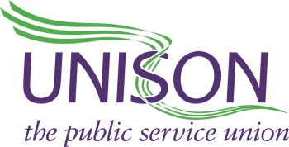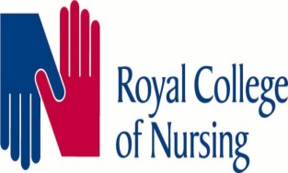
Dear Member
The Trust has recently released its proposal to change the terms and conditions around the current meal break provision.
This will be a huge change to the current agreement, and staff side feel will have a detrimental effect on member’s health and wellbeing for a number of reasons. The proposal may also have a detrimental effect on patient care.
Currently members are unpaid for their meal break, returned to their base station, and as such it is their time to take as they wish, many use this time to go home to check on relatives, check on pets or take personal medication in private and the comfort of their own home.
When members return to their base station there are a number of benefits, not least the chance to relax and ‘switch off’ in familiar surroundings which has an obvious effect on supporting good mental health and wellbeing, it also allows the member to store their food safely, at the station that they started their shift, instead of carrying their food with them for a number of hours on a vehicle that isn’t designed for that purpose.
It is also felt that if this new process is allowed to be implemented patient care will suffer as many times crews from rural areas are required to take patients into the larger urban area hospitals, with this meal break proposal in place, these crews that provide a vital service to the rural areas will be no longer available, as they will be tied up in the cities/towns, effectively creating a postcode lottery with the rural areas the ones to lose out as the cover provided by crews returning to their base station will no longer be there.
For the trust to include the end of shift in this proposal, in a take it or lose it all deal, we feel is against the Trust values of integrity and compassion, as the trust know that the changes to end of shift should benefit the members and save the Trust money, so why wouldn’t they do that anyway without trying to alter the meal break as part of the deal.
We can fully understand why members may be tempted by a £1500 before tax payment so soon after what can be an expensive holiday period, but this is a one off payment none recurring, that long term will mean members are financially worse off, and most likely because of the issues raised above, health wise worse off.
The joint recognised trade unions are recommending rejection of the proposal.
It will be a straight accept or reject vote, with the closing date being 30th December 5pm. Please email yas.staffside@nhs.net in order to vote. Please include your name and role i.e. Clinical Supervisor, student Paramedic etc. in the email

