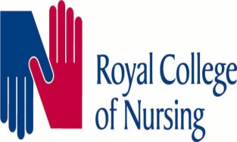

Trust Meal Break Proposal
Ballot Results

The votes have been counted, with all Trade Unions present, with a return of 1857 votes.
The results are as follows:
Reject- 91.7%
Accept 7.9%
Spoilt- 0.4%

This is a resounding rejection of the Trusts proposals.
All recognised Trade Unions wish to thank members for their participation and overwhelming support in this ballot.
Staff- side are now awaiting a response from the Trust and will keep members updated on any developments. .

