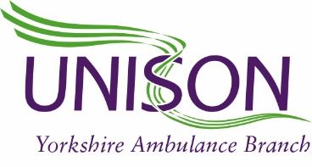

Dear member,
The Trust recently informed Staff-side it was their intention to pair up RRV members to work on a DCA. This was done without any formal consultation or evidence of why the changes were needed. Over the past few days Staff-side have been consulting with members and raising their concerns.
As a result of this grievances have been lodged on your behalf. After meeting with the Trust yesterday, Staff-side can confirm that members concerns have been taken into consideration and an agreement has been reached. RRV members will start to work on DCA’s over the next couple of weeks; remaining on their current rota line and at their base station. They will be crewed with another member of staff working the RRV rota.
In order to minimise exposure it has been agreed by the Trust that if this colleague is absent due to sickness or annual leave then the RRV member can only work with one other person. This mitigates the possibility of working with multiple workmates which happened in the last wave. Should both of these members be unavailable then the RRV member of staff will revert to their original role on the RRV and not be crewed with another colleague.
We have also insisted that this agreement includes relief staff; they should not be allocated shifts with more than 2 different members of staff as per the above. It has been agreed with the Trust that this interim change will be reviewed on a monthly basis at the Ops Joint Steering Group.
Staff-side are also aware that many DCA members have raised concerns that they work with more than 2 other members of staff. We are aware that this is how many rotas are configured but with members AGREEMENT would enter discussions with the trust around a short term rota change to ensure smaller “bubbles” to minimise Covid exposure.
We are also aware that some RRV members are unable to work on a DCA. We advise these members to contact their local representative.
We also highlighted geographical differences in relation to a RRV in an urban area as opposed to a rural area. We raised that it should not necessarily be a blanket change across all CBU’s and it was agreed that this would be part of the monthly review after looking at data and demand.
Staff-side are aware that any change in working practices can have a knock on effect. This short term change has been agreed to mitigate risk.
If any member has any concerns regarding this please contact your local representative.

