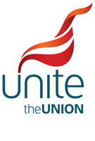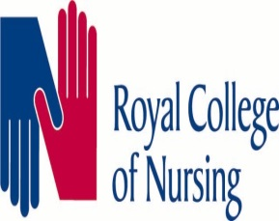
End of Shift Proposal

The end of shift/mealbreak vote has now closed.
Staff side received a large number of votes on the issue, and it certainly caused a great deal of discussion.
This is exactly what was wanted and is why members make the union.
As a result the initial proposal from the Trust was rejected, with many suggestions put forward as to how any future proposal could be improved and how it could look.
Staff side will take all these suggestion back to influence future discussions around end of shift with the Trust to help shape an improved proposal that members will once again have the chance to vote on.
Union | For | Against
UNISON | 27.12% | 72.88%
Unite the Union | 40% | 60%
GMB | 40% | 60%

