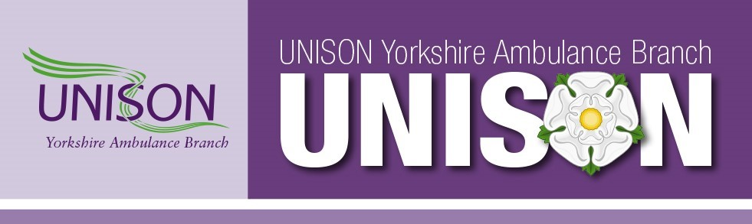
Together We Rise
Dear Member,
As I am sure you are all aware, there are several services, both public and private, that are currently either already taking industrial action or looking to act soon.
As always, most of the press is having a field day with sound bites and negative stories to try and discredit unions, all in an attempt to weaken their stance and paint a picture of greed. The government are doing the same, they want to ensure that when they throw the crumbs from their table to the greedy workers, it looks like they are the magnanimous leaders giving all that they can to poor ungrateful employees.
There are many groups of staff now disenfranchised with this government and the privateers profiting from soaring prices and low wages. The Rail Workers, Police Scotland, Lawyers, Post Office Workers, University Staff, Airline Staff, Airport workers, Civil Service and of course our own NHS. We cannot all be wrong, the stories of food banks inundated with customers are not. People who have a 'good job' are living hand to mouth, skipping meals to feed their children, they are having to choose whether to eat or heat their homes. This is not fake news; it is the stark reality of the crippling chasm that has developed between those who give and those who take. Prices are soaring and so many are struggling to pay their bills.
The Pay Review Body (PRB), which advises on wage rises for the NHS will have already made their decision and will undoubtedly have passed on their recommendation to the Government. The PRB are allegedly ‘independent’ but looking at the last ten years of NHS pay awards, when given evidence from both the unions and the government to consider, they certainly appear to value one more than the other.
Over the last few years, the real term drops in wages compared to the huge rise in the cost of living have created this perfect storm that we now find ourselves in. Every single one of us cares about our patients, but now is the time to stand up for them, to guarantee safe staffing levels, to improve service delivery and to maintain the exacting standards of the NHS. We must stop and demand change.
If animals were left in pain for hours with no treatment there would be a public outcry, action would be taken against their owner and people would demand answers. Yet it is a regular occurrence that a patient can wait hours for care, and it is ‘just the way it is.’ This is unacceptable and it should not be the way it is. If we are to improve care, we need to invest in care and the first step is to invest in the carers who provide that care. Our government will blame anything and everything so long as they do not have to take responsibility. The reality is the seeds were being sown many years before the effects of Russia’s war against Ukraine, Brexit or Covid, but any of those excuses will do. Cut after cut driving services and pay into the ground and forcing exceptionally dedicated staff to leave.
We recognise that taking industrial action is serious and no one wants services to be disrupted but without it there will be no change, but there will be further cuts and impacts on patient care. You are not being greedy in asking for a fair wage, one that allows you to support your family or get on the property ladder. You will be made to feel like you are out of order and asking for the moon on a stick. This is from MP’s whose wages have increased just under 30% since 2010 to over £84,000 for a basic starting wage (let us not talk about the added extras, expenses and second jobs etc.), but then again, they do play a big part in their own pay rise! The basic MP’s salary has increased every year since 2002 apart from 2020/21, those increases alone over the last few years now total more than some of our members earn for a full year as I write this letter.
Before long, the decisions that are being made now by all the workers named above and more; in companies and services throughout the British Isles, in deciding to ballot for industrial action and ultimately even strike, to stand tall and take action to fight back will soon be our decision to make. Which is why UNISON asks you and every other member to observe the strike, if called. Every member needs to vote, to not vote plays into the hands of the Government, your vote with UNISON counts! Together We Rise.
Kevin Fairfax, Bryn Webster
Branch Secretary, Branch Chair
UNISON Yorkshire Ambulance Branch
Please call UNISON Direct on 08000 857 857 to ensure your contact details are correct and up to date, do not miss out on having your say

