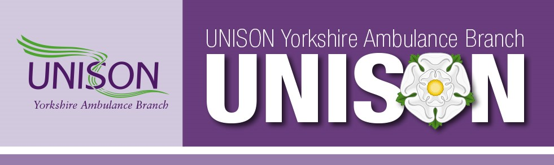
Dear member,
UNISON Yorkshire Ambulance Branch Committee is writing to let you know that UNISON's formal ballot for industrial action will run from the 27th October to the 27th November 2022. You will receive the letter with voting information and ballot papers in the post, it is vital that you fill out and return the ballot form that will be enclosed. By not returning the ballot form you lose your say in what will be an incredibly important vote for the NHS and UNISON.
We know that a strong return in favour of industrial action is often enough to make the Government sit up and listen. We want to avoid taking strike action, we care for our patients, it's our job, it's what we do, but we need to have it as an option should negotiations break down. We all see how cuts and poor staffing levels are affecting our ability to deliver the service our patients deserve, more cuts are not the answer, investment is, and the most important resource that can and should be invested in is you. A strong return in favour of action always shows the strength of feeling that our members have about their current pay and conditions. Every single ballot paper counts, the government has for years tried to silence the unions by making the balloting rules ever more difficult. Not returning your ballot paper means you don't have a voice in the vote and damages the unions stance against this government, we cannot emphasis enough the importance of returning the ballot form.
For years we have had below inflation pay, which in real terms means pay cuts, everything else rises except your wage. The time is now to say enough is enough. Below we have included some FAQs that we hope will help to allay any worries or concerns you may have.
You will have seen in the press that all the other unions involved with the NHS will also be balloting. UNISON is the biggest and strongest union within Yorkshire Ambulance Service and the NHS as a whole, we will lead from the front for our members, but we need your support, please return your ballot papers as soon as possible once you receive it in the post on or around 27th October.
What is the formal ballot?
You will be getting a letter in the post asking you if you wish to vote for industrial action. To vote, you simply mark your response and post it back (freepost). Government anti-union laws mean the final vote can only be done by post, so please make sure your address is up to date by ringing 0800 0857 857 , updating your details on the UNISON website or emailing yas.unisonvote@nhs.net with as much information as possible including old/new address.
Why should we vote?
For over a decade, the government has been imposing real-terms pay cuts on the NHS by giving below-inflation pay ‘awards’ and degrading our terms and conditions over time. This has left many of us earning an entire band less in real-terms than we were 10 years ago.
If we do not take action, the government will continue to suppress our pay, leading to more staff leaving, more overtime to make ends meet and worsening standards of living.
In 2016, the Tories introduced the Trade Union Act in order to make it more difficult for workers to negotiate for better pay – this means that locally to reach the legal threshold we now need to get over 1500 (50%) members to vote and over 1200 (40%) to say yes. So every single vote counts.
What is industrial action?
Industrial action is when workers reduce or withdraw their labour in order to attempt to get their employer to negotiate on pay and terms. It can include action short of a strike, which can take many forms including working-to-rule, slowing down the tempo of business, all the way up to a full strike, in which the workers refuse to work at all and often form a picket line outside the workplace.
Essentially industrial action is the democratic way workers exert their labour power to influence positive change in their workplace.
Why industrial action?
The NHS trade unions have consistently sought reasonable negotiation on pay with the government. Unfortunately, they flat-out refuse to negotiate with us, leaving us no other choice. The NHS is in crisis, with dangerously low staffing everywhere, harming the workers as well as our patients.
In any other business, we would be able to negotiate far better pay than is imposed on us now. The government is taking advantage of our good will, whilst at the same time suppressing our wages below inflation. Our members worked extremely hard and risked their health through Covid, only to be given a real-terms pay cut in the middle of the cost of living crisis that followed. At the same time the Trust is currently undermining our labour power by spending millions of pounds on private crews, instead of raising our wages to attract and retain more staff.
Employers and the government hold significant power over the workers, often using that power to gain short-term efficiencies at the expense of the financial and personal wellbeing of the workers. The strength we workers have in collective organisation and industrial action is that we can use our labour power to negotiate for a better future for our staff.
In short, we want pay to increase with inflation so our hard-working members can afford to live. A pay increase will also improve retention and increase recruitment, which will benefit patients and the Trust in the long term. If we do nothing, we will continue to see pay cuts, NHS privatisation and detriment to patients due to staffing shortages.
Does industrial action work?
Of course, otherwise the government wouldn’t be trying so hard to make it illegal. Recent industrial action at the bus company Arriva secured a pay increase of over 10% for its members. There have been many similar examples of trade union wins within Europe recently and within our Trust and across the NHS there have been many instances of negotiation. The best potential outcome is that by achieving a high return on the ballot, the union has the mandate to negotiate a better deal for staff without members having to withdraw their labour.
Can you be punished for industrial action?
There are certain protections in law for members who take legal industrial action following a successful vote. The Trust cannot target or punish individual members. Also, UNISON members make up such a large proportion of YAS that any action against us from the Trust would cause complete collapse of the service.
Do you get paid?
Though we will not get paid for the hours in which we withdraw our labour, UNISON's national industrial action fund is set up to help support members on strike, and at upto £50 for a full day it helps to lessen the impact of losing a days wages (the amount paid can't be more than your normal daily rate) the branch also has access to a local strike fund that could also help lessen the impact. UNISON also provides the opportunity to apply for financial support to any members who are struggling with this cost of living crisis or other financial issues through its 'There for You' welfare support system.
Of course nobody wants to lose any pay, but considering many of our members are losing thousands of pounds every year due to real-terms pay cuts, we feel that to do nothing and accept those pay cuts would be unacceptable.
What about patients?
The law means that the union and the Trust must provide ‘Life and limb’ cover to patients. UNISON Yorkshire Ambulance has set up an Industrial Action Committee, which will negotiate with the Trust to ensure that a minimum level of cover is provided and patients are safe. Members will not be put in an unethical position.
Doing nothing is also a choice. The lack of NHS industrial action over the last decade has allowed the government to cut services, causing far more harm to patients in the long term than any industrial action would. During the peak of austerity, cuts to NHS and social care services are estimated to have caused an extra 57,000 deaths in the UK over only 4 years. If we do nothing, cuts like this will continue to kill.
What can I do?
Please make sure your address is up to date in our system by checking online or ringing UNISON Direct on 08000 857 857. Once you get your ballot please vote ASAP. If you do not receive a ballot paper after the 27th October, contact your local rep, ring UNISON Direct on the number above or email yas.unisonvote@nhs.net (please include as much information as possible, old/new address, membership number, full name etc).
If you wish to get involved with how the ballot and potential industrial action is organised, get in touch with your local rep and ask to be involved in the Industrial Action Committee or as a ballot organiser.
UNISON Yorkshire Ambulance Branch will be sending out numerous notices relating to the industrial action ballot over the coming week, keep up to date with developments by subscribing to news updates at www.uyab.co.uk , follow us on Facebook our page name is Unison Yorkshire Ambulance Branch.

Yours sincerely

Kevin Fairfax
Branch Secretary
UNISON Yorkshire Ambulance Branch

