UNISON Direct 08000 857 857
Yorkshire Ambulance Branch
UNISON Weekly Update Number 8, 27th August 2018

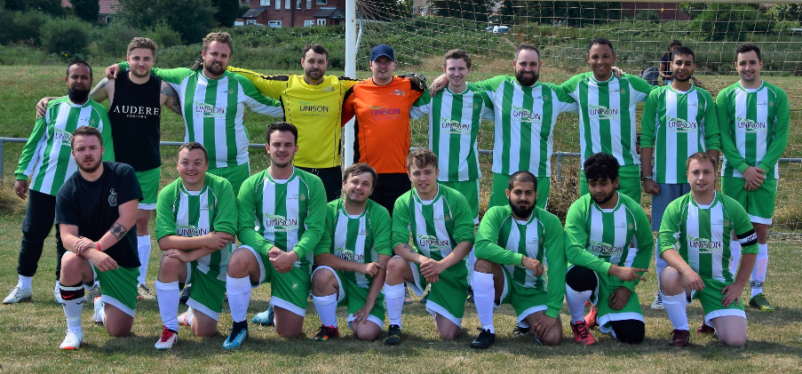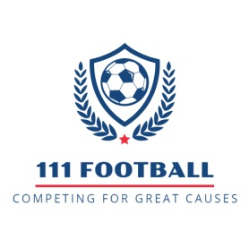

111 Football started out as a simple goal, to improve staff morale and engagement by holding a game between the Wakefield and Rotherham call centres, and raise awareness of nominated charities. This is how the 111 Cup was born. In February 2018 when two teams lined up to compete for the cup the match raised a total of £1251.10 for The Yorkshire Air Ambulance and Yorkshire Children’s Trust.
This journey has been helped greatly by Unison Yorkshire Ambulance Branch who is our exclusive shirt sponsor. The idea behind the 111 football matches up with UNISON’s national drive to promote and encourage staff health and wellbeing. The theme of promoting staff engagement and mental health support unifies YAS 111 football and UNISON Yorkshire Ambulance Branch perfectly. Together we can work towards a happier and more satisfying work place where employees can feel supported and able to express any issues relating to mental health.
After this initial success we pushed forward to arrange future matches with that same original aim in mind of raising staff morale and engagement. On top of this we sort to have an active social media presence. Setting up pages on face book, twitter and Instagram, also setting up a merchandise store you can access through the face book page.
In line with our aim to increase our visibility we have recently organised a Trust wide 5-a-side tournament for YAS staff which will take place at the end of September. Incorporating teams Trust wide. The organisation of this tournament has been acknowledged at the highest levels of YAS.
As well as the 5-a-side there are 4-5 more matches that have been arranged before years end. Including an 11-a-side celebrity charity match against AFA FC (Action for Autism), so we are hoping to put on a good performance and raise a good amount of money and awareness for charity. These will be updated on our Facebook and twitter profiles.
Under the banner of 111 Football & Events we compete against other charity football teams across the region, raising money for their causes and our own Yorkshire Ambulance Service Charity. What began as a one off game has quickly evolved into a proactive and morale boosting innovation, resulting in increased staff engagement and morale.
Games against the ever growing AndysManClub movement (part of the #ITSOKAYTOTALK campaign), and the Leeds Adult Transplant Sports Team from the Leeds Teaching Hospital went off successfully. Both were well attended, allowing us to keep raising awareness of our competitor’s charitable causes as well as the YAS Charity and the 111 Football brand.
Please give our Facebook page 111 Football & Events a Like and follow us on Twitter:
: https://www.facebook.com/111Football/ : https://twitter.com/YAS111Football

