**Come and discover the world of UNISON Learning.**

**Join us for a residential weekend full of informal, friendly, informative and fun taster workshops**.

**FLASH FICTION** **HEALTH & WELL-BEING**

**ANCESTRY TRACING**

**AND MUCH MORE!**

**CALLING ALL UNISON MEMBERS – FREE TRAINING JUST FOR YOU!**

**RECONNECT WITH LEARNING AND.......**

**FULFIL YOUR POTENTIAL WITH UNISON**

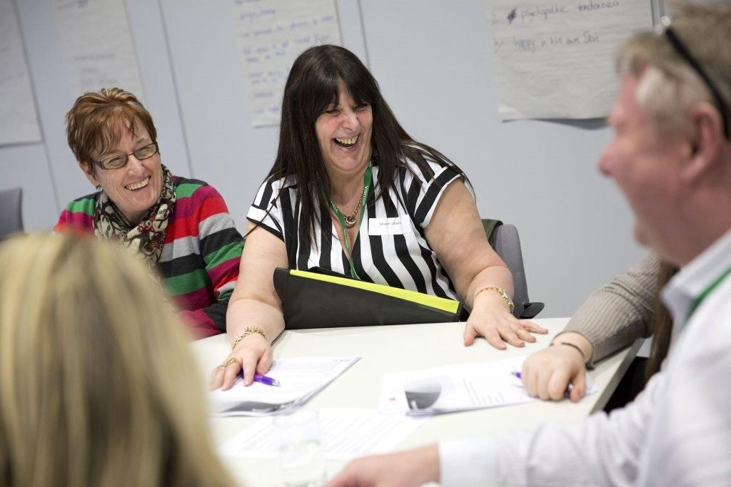

Overnight accommodation will be arranged for you and if you need childcare we will arrange a crèche.

***DATE:* 24, 25 November 2018**

(From **Saturday morning until Sunday lunchtime)**

**VENUE: DoubleTree by Hilton Hotel, Leeds**