UNISON Direct 08000 857 857
Yorkshire Ambulance Branch
Number 14, 8th October 18
UNISON Weekly Update
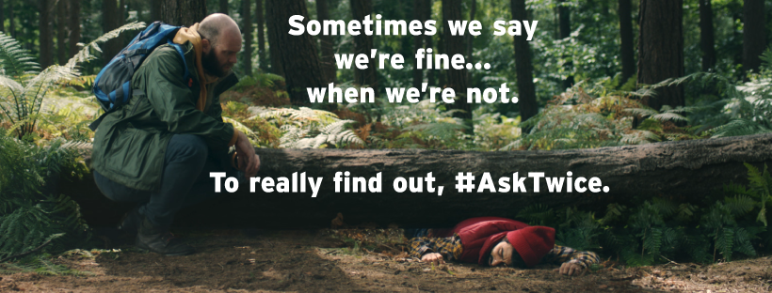

Wednesday 10th October is World Mental Health Day. With one in four people experiencing a mental health problem this year alone, it is a good time to reflect on our own mental health and that of our family, friends and colleagues.
If you notice that someone isn’t their usual self, ask them how they are. If they say ‘Fine’ ask them again, (‘are you sure?’). Sometimes we say we’re fine when we’re not. Just asking again show’s that you’ve noticed. That can have a huge impact on someone with a mental health problem. It can make them feel that they’re not alone and that feeling could save their life!
You don’t need all the answers; just listening and chatting, (over a cuppa), is often all it takes.
For more information visit: www.time-to-change.org.uk

UNISON Surveys
In UNISON we take equality seriously, below are two surveys that were first run in 2016. We would like to see what has changed, if anything, and are asking members to please complete the surveys so as a Branch we can feed back to the Trust and take the lead in pushing through change for all our members, to improve their working lives. Simply copy/click the link or use your smartphone QR scanner on the QR code below the appropriate survey heading. Remember many disabilities are hidden but can affect your everyday life, e.g. Mental Health, diabetes etc. All responses are Anonymous
https://www.surveymonkey.co.uk/r/HR293BH BME Members survey
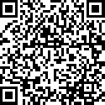
https://www.surveymonkey.co.uk/r/HL9Y965 UNISON Disability survey
